**Student Name: Weight: 2.3%**

**Student ID:** **Marks:** **/15**

# Lab: Single Row Functions

## Equipment and Materials

For this lab, you will need:

* A Windows computer with a minimum of 16GB RAM and 250GB of free disk space, capable of nested virtualization
* Access to ORACLE SQL*PLUS
* Really Cheap Vacations Database created as part of previous learning activities
* Physical model for Really Cheap Vacations as created during previous learning activities
* The file **Labskeleton.sql**,which is found in the Course Resources section of Brightspace.

## Instructions

1. First, work through steps 2-5 individually. Then arrange a time to come together with your small group. As a group, create one solution based on the best individual script for each problem. Further refine the solution as a group as needed.
2. Use the existing Really Cheap Vacations database and physical model to complete this lab.
3. Review the Really Cheap Vacations Physical Model.
4. Review the Really Cheap Vacation Database.
5. Using **Labskeleton.sql**as a starting point, write a single script that satisfies all the requirements outlined in the Problem Set.
6. Review the Tips for Success and Marking Criteria sections. Adjust your script as needed.
7. See Brightspace for exact due dates.
8. Only one submission is required per group. The submission should include:
   1. One script file
   2. One spool file showing all results
   3. One attribution list that outlines the activities associated with completing this assignment. A sample attribution list is provided on Brightspace.

## Problem Set

1. Show all the vacations taken my Amy Fowler. Show the duration of the tour in days. Show the first 15 characters of the tour description. Break on the tour description and start date to avoid duplicate values from being output.  
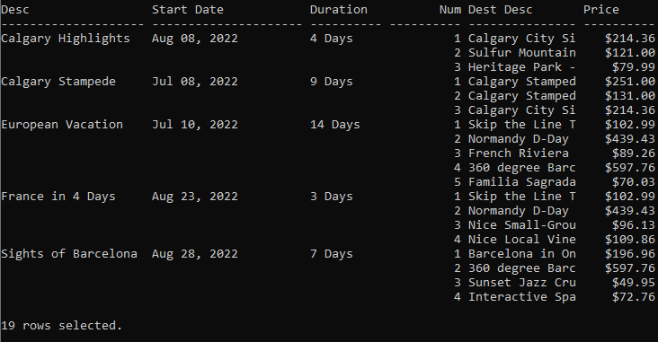

2. Show a list of all the destination tours available outside of Canada and the United States. For the tour cost column, convert the price to a number of dollar signs ($) based on the following table:

|  |  |
| --- | --- |
| Price | # of dollar signs |
| Less than 50 | $ |
| $50- less than $100 | $$ |
| $100-less than $200 | $$$ |
| $200-less than $500 | $$$$ |
| $500 and over | $$$$$ |

The country names should be all uppercase. Sort based on country, city and then the tour cost.

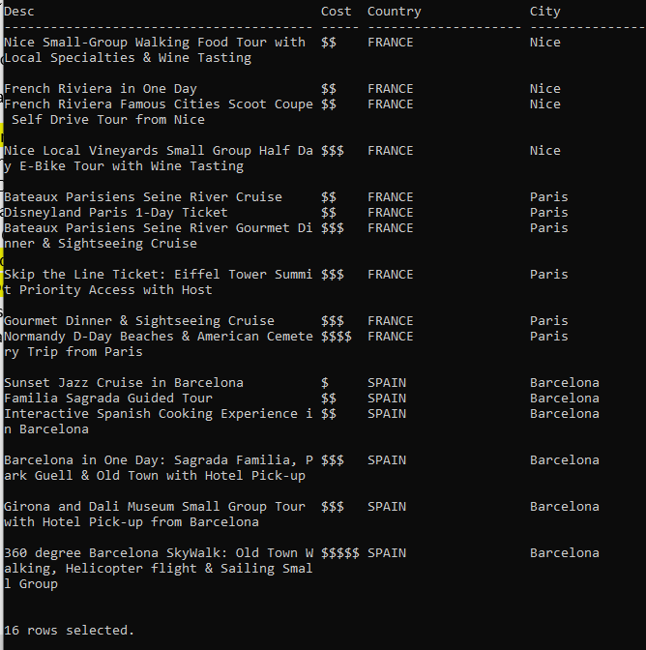

3. Find all the food-related tours, which will have one of the following words in the destination description: Cook, Wine, or Dinner. Don’t use LIKE to solve this, instead use INSTR(). A country name of ‘United States’ should be shown as ‘USA’. If the state is null, show it as ‘NA’.

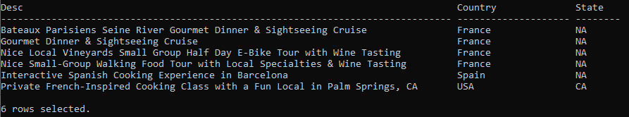

## Tips for Success

1. Use column aliases to create appropriate column headers.
2. Use **set linesize xxx**, where xxx is a number to set the width for the output.
3. Use the column command to set the size of the columns, e.g.:  
   **column “aliasname” format A40**

**column stagename format A30**  
“A” means alphanumeric field, with a length of 30 characters in the example above.

1. For number columns use

**column “aliasname” format 9999.99**   
This will show four digits before the decimal point and two digits after the decimal point.

1. Use **clear columns;** at the end of each query to reset the column size.
2. Use the following format for breaks:  
   break on *columnname/alias* [on *columnname/alias*]

## Marking Criteria

|  |  |  |  |  |  |
| --- | --- | --- | --- | --- | --- |
| **Categories** | **Missing 0** | **Needs Improvement 1** | **Good 2** | **Excellent 3** | **Score** |
| Correct Results (e.g. number of rows, values) | N/A | 2+ questions incorrect | 1 question incorrect | Yes | **/3** |
| Output is formatted to match what is provided | No attempt to format output | 3+ formatting issues, lines wrap in output | 1-2 formatting issues | Yes | **/3** |
| Solution will work on all datasets (e.g. no hard-coded values) | 4 questions will not work for all datasets | 2-3 questions will not work for all datasets | 1 question will not work for all datasets | Yes | **/3** |
| Attribution list provided | No |  |  | Yes | **/3** |
| Spool file provided with commands included | No |  |  | Yes | **/3** |
| **/15** | | | | | |